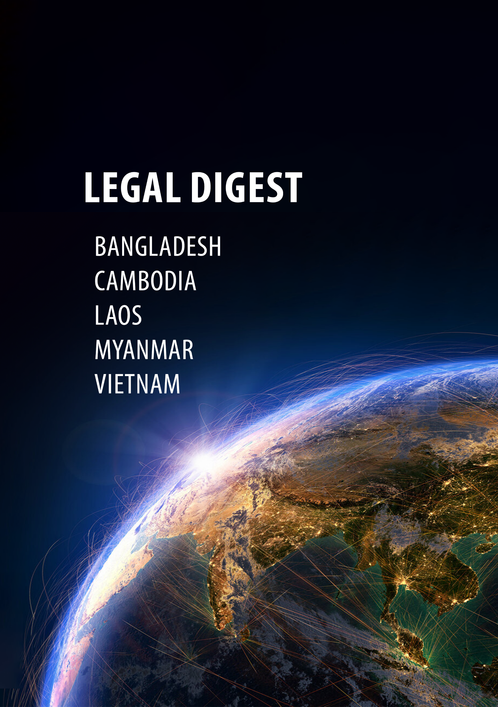

Legislative developments – **July 2023**

# BANGLADESH

## Banking and Finance

### Circular No. 01 dated 16 July 2023 issued by the Financial Sector Support and Strategic Planning Department of the Bangladesh Bank on “**Long-Term Financing Facility**”

In light of the notable success achieved through the completion of the long-term financing facility (“**LTFF**”) program under the Financial Sector Support Project, the Bangladesh Bank (“**BB**”) has decided to extend its provision of long-term financing support to private sector firms, particularly those in export-oriented manufacturing industries.

The primary objectives of this initiative are to stimulate employment opportunities, foster industrial growth, and drive the real output of the economy. Additionally, the program aims to facilitate the sustainable adoption of digital transformation in line with the principles of the Fourth Industrial Revolution in Bangladesh.

The financing will be facilitated through banks authorized to engage in foreign exchange transactions, referred to as participating financial institutions (“**PFIs**”). To be eligible to participate, PFIs must meet several qualifications. These include having a minimum rating of three or better in capital adequacy, asset quality, management, earnings, liquidity, and sensitivity ratings, as determined by the BB. Additionally, PFIs must maintain a proportion of non-performing loans of less than 8% and comply with the minimum regulatory capital adequacy requirement. Problematic banks, such as those involved in major financial scams, or those under the observation or coordination of the BB are not eligible to participate.

Under the BB-LTFF, loans amounting to as much as US$10 million will be offered in US currency based on the provided guidelines. Borrowers can apply to a single PFI for a maximum of US$5 million, loans of up to US$10 million are available under syndicated financing through multiple PFIs. Refinancing of loans disbursed before 1 January 2021 using the fund is not allowed.

The funds can be utilized for various purposes, such as procuring capital machinery, covering installation expenses, and facilitating the expansion or establishment of new manufacturing industries. Financing also supports the acquisition of ocean-going vessels and specialized transport vehicles for transporting domestically-manufactured goods, as well as the establishment of businesses that adhere to environmental and social standards.

However, financing will not be provided for loans that have direct economic, social, or environmental impacts, such as those involving land acquisition, involuntary resettlement, affecting indigenous communities, and leading to the loss of income sources or livelihoods.

The loans offered through the BB-LTFF will have a maturity period of three to ten years, which includes the grace period. The PFIs will be responsible for determining the specific grace period for individual projects based on projected cash inflows, ensuring it does not exceed one year.

Regarding interest rates, PFIs will be subject to an indicative pricing range of plus 0.25% to 1.25% of the 180-day average Secured Overnight Financing Rate, which is the benchmark interest rate for dollar-denominated derivatives and loans, replacing the London Interbank Offered Rate.

PFIs will independently set the loan interest rates for borrowers, taking into account their borrowing costs and operational expenses, and incorporating a reasonable risk-adjusted spread and profit margin ranging from 1% to 2% above the cost of funds.

## Public-Private Partnerships

### Invitation for Bid (“IFB”) Notice (Re-Tender) dated 13 July 2023 on the “**Development of the Magura Textile Mills Site at Magura, Bangladesh through a Public-Private Partnership (“PPP”)”**

Bangladesh Textile Mills Corporation (“**BTMC**”), under the Ministry of Textiles and Jute, intends to establish textile mills and/or textile-related linked industries and support facilities at Magura, Bangladesh at the existing site of Magura Textile Mills Limited through PPP model.

BTMC is inviting interested bidders and bidding consortiums to participate in the selection of a private partner through an international competitive bidding process as per the terms and conditions set out in the PPP contract.

Bids are being accepted until 18 September 2023. Details on the project, bid submission process, and other requirements are delineated in the IFB document.

### Invitation for Bid Notice (Re-Tender) dated 13 July 2023 on the “**Development of the Dost Textile Mills Site at Feni, Bangladesh through a Public-Private Partnership”**

BTMC intends to establish textile mills and/or textile-related linked industries and support facilities at Feni, Bangladesh at the existing site of Dost Textile Mills Ltd. through PPP model.

BTMC is inviting interested bidders and bidding consortiums to participate in the selection of a private partner through an international competitive bidding process as per the terms and conditions set out in the PPP contract.

Bids are being accepted until 18 September 2023. Details of the project, bid submission process, and other requirements are delineated in the IFB document.

### Act No. 19 dated 11 July 2023 passed by the Parliament of the People’s Republic of Bangladesh on “**Amendment of the Bangladesh Public-Private Partnership Act 2015**”

The amendment to the Bangladesh PPP Act seeks to limit the powers of the PPP Authority in terms of financial and administrative powers and the performance of its functions. Prior to the amendment, the PPP Authority had the right to independently carry out its functions, that has now been changed, with authority back in the hands of the government.

Another change is the addition of a new subsection that says that upon signing the PPP agreement, the relevant government institutions are obligated to extend the necessary support to the project company to facilitate the smooth implementation of the project.

# CAMBODIA

## Competition Law and Commerce

### Decision No. 179 dated 14 June 2023 issued by the Ministry of Commerce on the “**Formalities and Procedures for the Issuance of an Advance Ruling Certificate**”

This decision outlines the formalities and procedures for the issuance by the Cambodian Competition Committee ("**CCC**") of an advance ruling certificate for a business merger in accordance with Article 14 of Sub-Decree No. 60 dated 6 March 2023.

Before the completion of the main parts of the business merger, an application for an advance ruling certificate must be submitted to the General Department of Consumer Protection, Competition, and Anti-Fraud ("**CCF**"). Within seven working days of receiving the application, the CCF must notify the applicant of the documents and information required for inspection and evaluation.

After completion of the CCF inspection, an advance ruling certificate will be issued. However, if it is found later that the documents and information provided are inaccurate or inadequate, the CCC can issue a statement suspending the advance ruling certificate that was issued.

The party receiving the notice of suspension has seven working days from the date of receipt to provide additional evidence. If the CCC determines that the evidence provided is correct and sufficient, notice of the cancellation of the suspension will be issued.

If the CCC does not lift the suspension, the advance ruling certificate will be annulled after seven working days from the date of issuance of the notice of suspension.

Despite parties having an advance ruling certificate, the CCC can still forbid the business merger if violations occur in accordance with Article 11 of the Competition Law within a year from the date of issuance of the advance ruling certificate.

### Notification No. 2241 dated 30 June 2023 issued by the Ministry of Commerce on the “**Implementation of the Consumer Protection Law and Issuance of Prakas No. 0067 on Unfair Promises in Real Estate and Housing**”

In 2020, as part of the draft of the Consumer Protection Law (which was subsequently issued in 2021), the Royal Government of Cambodia established the National Commission for Consumer Protection (“**NCCP**”) under Sub-Decree No. 135. The notification provides information on the law’s implementation and also addresses practices with regard to real estate and housing in Cambodia.

The NCCP is responsible for drafting policies, strategic plans, and overseeing the effective implementation of the Consumer Protection Law. Cambodia’s economy is rapidly growing in various sectors, including real estate and housing.

The NCCP urged real estate businesses to comply with the Consumer Protection Law and related regulations, promoting transparency and protecting consumer rights.

# Laos

## Manufacturing and Construction

### Decision No. 2897/AF dated 14 July 2023 issued by the Minister of Agriculture and Forestry on “**Fertilizer Factory Management**”

The decision provides guidance on the process and required documents to establish and operate a fertilizer factory. It is applicable to domestic and foreign investors who wish to establish and operate a fertilizer factory, except for a factory for fertilizer for household use.

Investors must go through a two-step approval process—first obtaining permission to build the factory and then obtaining a factory operation license to actually go into production.

Investors must meet the following conditions:

* Be a legal entity registered in accordance with the Lao Enterprise Law.
* Have sufficient funds to build a factory, and have the necessary materials, machinery, and vehicles for production.
* Have a qualified technician who have previous experience working in the fertilizer industry.
* Have a place to build the factory, a place to store the raw materials, a place to handle waste water, and sources for the raw materials.

To obtain permission to build the factory, investors must submit an application in the template form (F1) with the following documents attached to the Ministry of Agriculture and Forestry (“**MOAF**”) for consideration:

* Economic and technical assessment of the factory
* A copy of the environmental certificate
* A copy of the construction license
* A copy of the company’s bank statements
* A copy of the land lease agreement, land ownership certificate, or land title deed
* Copies of the company’s corporate documents, such as the enterprise registration certificate, tax payment certificate, investment license, etc.

The MOAF will conduct a factory location inspection, and if all is in order, issue, within 10 working days of the inspection, a permission to the company to allow it to proceed with the factory construction, and equipment and facilities installation.

After completion of the construction and installation, the MOAF will check the factory and all equipment and facilities installed to confirm that the required conditions and standards have been met. After this, a fertilizer production test must be conducted and approved by the MOAF.

If the factory passes all of the above reviews by the MOAF, the investor must then apply for a fertilizer factory operation license by submitting to the MOAF an application in the template form (F2) with the following documents attached:

* The MOAF’s decision or permission to allow the company to process the factory construction
* Production diagram with explanation
* A list of the factory machinery
* Annual plan of the factory
* Construction plan and the technical systems of the factory’s machinery in accordance with the regulations governing construction
* A copy of the certificate of the treatment plan and/or of the factory’s release of waste as specified in the relevant laws and regulations
* A copy of the environmental certificate
* A copy of the land lease agreement, land ownership certificate, or land title deed
* Copies of the company’s corporate documents, such as the enterprise registration certificate, tax payment certificate, investment license, etc.
* A copy of the Lao managing director's ID or family book, or the international managing director’s passport ID page
* Four 3x4 cm size photos of the company’s managing director taken no more than three months earlier
* Power of attorney appointing a representative to submit the application for and on behalf of the company

After receiving all required documents, the MOAF will conduct a final inspection of the factory. If all is in order, the MOAF will issue a fertilizer factory operation license to the company within five working days.

The fertilizer factory operation license will be valid for three years and is renewable.

This decision enters into effect on 17 August 2023.

## Foreign Exchange

### Decision No. 652/BOL dated 12 July 2023 issued by the Bank of the Lao PDR on the “**Market for the Purchase and Sale of Foreign Currencies Between Banks**”

The decision is applicable to commercial banks engaged in the interbank foreign exchange (“**FX**”) market.

In order to make transactions in the interbank FX market, third parties need to obtain permission from the Bank of the Lao PDR (the “**BOL**”) and may then only do so through commercial banks that are members of the market.

**Transactions**

The various foreign currency market transactions consist of:

* FX spot transactions
* FX forward transactions
* FX swap transactions
* FX options transactions

**Permitted currencies**

The US dollar, the Thai baht, the Chinese yuan, or the currency of any other nation that does business with the Lao PDR are accepted currencies in the interbank FX market.

**Opening and closing times**

The interbank FX market is open from 9:00 am to 3:30 pm every business day.

**Payments for transactions**

Payments for FX transactions must be made through the payment and debit system of the Lao PDR.

* FX spot transactions must be paid for on the transaction date.
* FX forward, swap, and options transactions must be paid for on the date specified in the contracts.

If the payment date falls on a Saturday, Sunday, or public holiday, payment must be paid on the next business day after the payment date.

### Notification No. 14/BOL dated 13 July 2023 issued by the Bank of the Lao PDR on “**Carrying Cash Into and Out of the Lao PDR**”

In order to make the Decision on Opening Bank Accounts, Money Transfers, and Carrying Cash Into and Out of the Lao PDR No. 454/BOL dated 30 May 2019 (“**Decision 454**”) consistent with the current economic situation of the Lao PDR, the maximum amount of cash in Lao Kip and foreign currency that can be carried into and out of the Lao PDR has been increased, from an amount equivalent to LAK100 million to an amount equivalent to LAK150 million.

Any person entering the Lao PDR with cash in Lao Kip or foreign currency in an amount equivalent to more than LAK150 million must declare it to the customs authority at the border checkpoint using the standard declaration form and present the cash for inspection. To take cash in Lao Kip or foreign currency equivalent to more than LAK150 million out of the Lao PDR, it must first be authorized by the BOL’s Foreign Exchange Management Department using the standard declaration form.

This notification replaces the first and second paragraphs of Article 10 of Decision 454.

### Decision No. 677/BOL dated 24 July 2023 issued by the Bank of the Lao PDR on “**Foreign Currency Management on the Import and Export of Goods and Services**”

The BOL is increasing its utilization of foreign exchange control mechanisms across the country as part of efforts to regulate foreign currencies and stabilize the value of the Kip.

The decision specifies that importers must utilize only import-export deposit accounts to make electronic payments for products and services abroad. Additionally, exporters must deposit the funds received for goods and services provided abroad into their import-export deposit account via electronic money transfer. For services, the funds must be deposited on the payment date specified in the contract, but for goods, the funds must be deposited not more than 180 days after the date of shipment from the customs border

To obtain a certificate of importer-exporter registration notification to be able to open an import-export deposit account with a commercial bank, importers and exporters must apply to the BOL within 10 working days of the date they obtain an import-export license from the industry and commerce section.

The documents required to obtain a certificate of importer-exporter registration notification are:

* An application in the standard form provided by the BOL
* A copy of the import-export license
* A copy of the company’s investment license and/or enterprise registration certificate
* A copy of the business operation license, if any

The BOL will consider the application and issue a certificate within five working days after receiving all required documents.

After obtaining the certificate, Importers and exporters must open an import-export deposit account with a commercial bank within 10 working days.

## Banking and Finance

### Decision No. 667/BOL dated 19 July 2023 issued by the Bank of the Lao PDR on “**Financial Services Dispute Resolution**”

The decision is applicable to service users and financial service providers who are unable to reach a compromise with the other parties in a financial dispute or in the event that one party rejects or fails to consider the other party’s proposal. In these cases, the BOL will settle the dispute as proposed by the service users or financial service providers.

The decision stipulates the dispute resolution procedures, the types of disputes to be resolved, the procedures for submitting a request for mediation, and the implementation of the results of the mediation.

# MYANMAR

## Banking and Finance

### Notification No. 15/2023 issued by the Central Bank of Myanmar dated 13 July 2023 on the “**Reduction in the Mandatory Percentage of** **Export Earnings to be Converted**”

Through this notification, the Central Bank of Myanmar (“**CBM**”) announced the reduction in the percentage of export earnings that must be converted into Myanmar Kyats by exporters from 65% to 50%, effective from the issue date of 13 July 2023.

### Letter No. FE-1/882 issued by the CBM dated 3 July 2023 on the “**Remittance Procedure for the Importation of Goods**”

Engaging in trade activities is restricted to those with a valid license. Any payment transfers for imports made prior to obtaining a license will be deemed ineligible. This letter outlines the procedure licensed authorized dealer banks (“**AD Banks**”) must follow on the remittance of payments for imported goods.

* They should check the validity and legitimacy of the approval date of the license and confirm that it matches the shipping date and identification (“**ID**”) date. AD Banks must refrain from submitting cases where the license date is later than the ID date.
* AD Banks should also verify that the submitted ID was obtained within three months of acquiring the license, and if the ID was obtained later, then examine whether the license has been renewed.
* Due to the prohibition against advance payment telegraphic transfers (“**TTs**”) for imports, AD Banks must scrutinize any requests for advance payment to determine if there are compelling reasons for the request and only then seek permission from the CBM for that particular case.

### Announcement issued by the CBM dated 23 July 2023 on the “**Issuance of a** **New MMK20,000 Banknote**”

The CBM announced that a new MMK20,000 banknote will be issued starting from 31 July 2023. A limited number will be distributed only by exchanging it for the same value of various types of old banknotes. Initially, old banknotes can be exchanged for their equal value at the Central Bank of Myanmar in Nay Pyi Taw, as well as at the Yangon and Mandalay branches.

The current valid currency notes and changes will remain in circulation.

## Export and Import

### Newsletter No.12/2023 issued by the Ministry of Commerce dated 3 July 2023 on “**Revised Regulations on the Export and Import of Value-Added Gold Products, Jewelry, Gold Arts and Accessories**”

Revised regulations have been issued under this newsletter effective from the date of issue and supersede those under newsletter bulletin no. 10/2020.

They specify that an export license for value-added gold products, jewelry, gold arts and accessories can be obtained through either a letter of credit or a TT (the TT is a new addition). Exporters dealing with value-added gold products, jewelry, gold arts and accessories are required to adhere to the separately issued Export and Import Standard Operating Procedures.

### Notification No. 5/2023 issued by the Union Government dated 4 July 2023 announcing “**Online Trading as an Important Service**”

The Union Government announced that online trading is considered an important service as per Section 4(c) of the Important Goods & Services Act 2012. The Ministry of Commerce is also vested with the authority to issue orders regarding important services.

As part of this authority, the Ministry of Commerce issued Notification No. 50/2023 on 21 July 2023 stating that a registration certificate must be obtained in order to carry out online trading. Those failing to do so will be subject to imprisonment for a term of from six months to three years and will also be liable for a fine not exceeding MMK500,000 in accordance with Section 5 of the Essential Supplies and Services Law 2012.

# VIETNAM

## Banking and Finance

### Circular No. 09/2023/TT-NHNN dated 28 July 2023 issued by the State Bank of Viet Nam on “**Guidance on the Implementation of the Law on Anti-Money Laundering**”

This circular prescribes the criteria and methods for assessing money laundering risks of reporting entities; risk management procedures for money laundering risks and customer classification based on money laundering risk levels; internal regulations on anti-money laundering; reporting of large transactions; reporting of suspicious transactions; electronic funds transfer; reporting of electronic funds transfer; and the format and deadlines for reporting of electronic data.

* * *

*\* Information included in this document does not represent legal, tax or other advice. This document is not intended to represent a comprehensive list of all new laws and regulations issued or published in the relevant jurisdictions.*